Logistic Regression Training vs. Testing
Laboratory Exercise 6

Antonio, Daniel
Electronics and Communications Engineering Department
De La Salle University - Manila
Manila, Philippines

Eco, Lance Randall Lim
Electronics and Communications Engineering Department
De La Salle University – Manila
Manila, Philippines
lance_eco@dlsu.edu.ph

Tan, Sidney Sheldon Urlanda
Electronics and Communications Engineering Department
De La Salle University - Manila
Manila, Philippines
sidney_tan@dlsu.edu.ph

Zarzoso, Aaron John Pascua
Electronics and Communications Engineering Department
De La Salle University - Manila
Manila, Philippines
aaron_zarzoso@dlsu.edu.ph

Abstract— This document represents the students’ lab report for experiment 6 of the course LBYCP29. It contains the procedures done in the implementation of training vs testing however it is in done specifically with respect to the process of logistic regression. It also contains the implementation of logistic regression in such a way that it would be incorporated to the idea of training and testing data.
Keywords— matlab; octave; logistic regression; training; testing; optimization; accuracy;

Introduction
Logistic regression is a kind of regression that predict the occurrence of an instance by combining information to the logistic size. It has the ability to indicate variables which could be numerical as well as categorical. This type of regression is the best way in performing the correct decision. This will assist for the computation of the dependent variables over several number of independent variables with the help of probability estimation of a logistic function.

Instructions/procedure
- Calls ex1_load_mnist.m to load the MNIST training and testing data. In addition to loading the pixel values into a matrix X (so that that j’th pixel of the i’th example is Xji=x(i)j) and the labels into a row-vector y, it will also perform some simple normalizations of the pixel intensities so that they tend to have zero mean and unit variance. Even though the MNIST dataset contains 10 different digits (0-9), in this exercise we will only load the 0 and 1 digits — the ex1_load_mnist function will do this for you.
- The code will append a row of 1’s so that θ0 will act as an intercept term.
- The code calls minFunc with the logistic_regression.m file as objective function. Your job will be to fill in logistic_regression.m to return the objective function value and its gradient.
- After minFunc completes, the classification accuracy on the training set and test set will be printed out.
- Implement logistic_regression.m to loop over all of the training examples x(i) and compute the objective J(θ;X,y). Store the resulting objective value into the variable f. You must also compute the gradient ∇θJ(θ;X,y) and store it into the variable g. Once you have completed these tasks, you will be able to run the ex1b_logreg.m script to train the classifier and test it.
- If your code is functioning correctly, you should find that your classifier is able to achieve 100% accuracy on both the training and testing sets! It turns out that this is a relatively easy classification problem because 0 and 1 digits tend to look very different.

Data and results

Procedure 1
In procedure 1, ex1_load_mnist.m was called to load the MNIST training and testing data wherein normalizations of the pixel intensity was done to ensure that they have a zeron mean and unit variance.
Codes:
%loads the training and testing data
>> binary_digits = true;
>> [train, test] = ex1_load_mnist(binary_digits)

train =

X: [784x2115 double]
y: [1x2115 double]

test =

X: [784x2115 double]
y: [1x2115 double]
%append
>> train.X = [ones(1,size(train.X,2)); train.X];
>> test.X = [ones(1,size(test.X,2)); test.X];
>> m = size(train.X,2);
>> n = size(train.X,1);
%trains logistic regression classifier
>> options = struct('MaxIter', 100);
%initializes theta to a small random value
>> theta = rand(n,1)*0.001;
%implementation of batch logistic regression in the logistic_regression.m file
>> tic;
>> theta = minFunc(@logistic_regression, theta, options, train.X, train.y);
>> fprintf('Optimazation took %f seconds.\n', toc);
Optimazation took 173.783463 seconds.

Procedure 2
Procedure 2 requires the implemention of batch logistic regression in logistic_regression_vec.m and to use MATLAB's vectorization features to speed up our code. The group also compared tthe running time for the logistic_regression.m and logistic_regression_vec.m implementations.

Codes:
%uncommented lines to run vectorized code
>>theta = rand(n,1)*0.001;
>>tic;
>>theta=minFunc(@logistic_regression_vec, theta, options, train.X, train.y);
>>fprintf('Optimization took %f seconds.\n', toc);
Optimization took 117.647188 seconds.
%prints out training accuracy
>> tic;
>> accuracy = binary_classifier_accuracy(theta, train.X, train.y);
>> fprintf('Training accuracy: %2.1f%%\n', 100*accuracy);
Training accuracy: 6.2%
%loads data for random shuffling and stardadization of Train data set
>> X = loadMNISTImages('t10k-images-idx3-ubyte');
>> y = loadMNISTLabels('t10k-labels-idx1-ubyte')';
>> if (binary_digits)
X = [ X(:, y==0), X(:, y==1)];
y = [ y(y==0), y(y==1)];
end
>> I = randperm(length(y));
>> y = y(I);
>> X = X(:, I);
>> s = std(X, [], 2);
>> m = mean(X, 2);
>> X = bsxfun(@minus, X, m);
>> X = bsxfun(@rdivide, X, s+.1);
>> train.X = X;
>> train.y = y;
%loads data for random shuffling and stardadization of Test data set
>> X = loadMNISTImages('t10k-images-idx3-ubyte');
>> y = loadMNISTLabels('t10k-labels-idx1-ubyte')';
>> if (binary_digits)
X = [ X(:, y==0), X(:, y==1)];
y = [ y(y==0), y(y==1)];
end
>> I = randperm(length(y));
>>y = y(I);
>>X = X(:, I);
>> X = X(:, I);
>> X = bsxfun(@minus, X, m);
>>X = bsxfun(@rdivide, X, s+.1);
>> test.X = X;
>> test.y = y;

Procedure 3
In procedure 3, the ex1b_logreg.m calls minfunc with logistic_regression.m for which the group inserted the code into the logistic_regression function which should yield a 100% accuracy value for both Training and Testing. Important variables/arrays used were: “theta”, a column vector containing the parameter values to optimize; “X”, examples that are stored in matrix form. “X(i,j)”, i'th coordinate of the j'th example; “y”, label; and “y(j)”, j'th label.
m=size(X,2);
%Initialize objective value and gradient.
f = 0;
g = zeros(size(theta));

The objective function was then calculated by looping over the dataset and summingup the objective values for each example. Answer was then stored in variable 'f'. The gradient of the objective was also calculated by looping over the dataset and summing up the gradients (df/dtheta). Answer was then stored in variable 'g'.

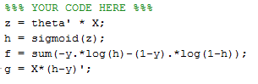

Procedures 4, 5, and 6.
Procedure 4 requires the display of training and testing set accuracy After minFunc completes. Procedure 5 requires the implementation of logistic_regression.m to loop over all of the training examples x(i) and compute the objective J(θ;X,y). Gradient ∇θJ(θ;X,y) was computed and stored into variable g. Then the group proceeded to run the ex1b_logreg.m script to train the classifier and test it.
Procedure 6 denotes that the classifier should be able to achieve 100% accuracy on both the training and testing sets to prove that our code is working correctly.

Preliminary tranining and testing accuracy values gathered by the group:
Training Accuracy was 6.2%
Test Accuracy was 6.2%
Optimization time was 0.348692 seconds.

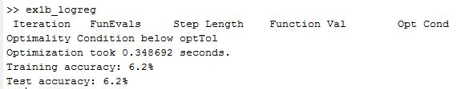

Final tranining and testing accuracy values:
Training Results was 100%
Test Accuracy was 100%
Optimization time was 0.517193 seconds.
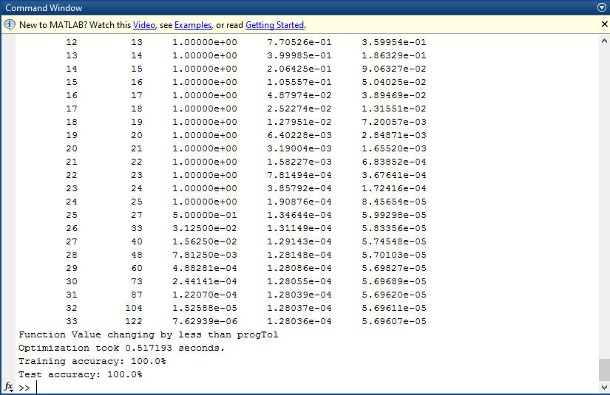

The group’s final training and test accuracy values were both 100% which indicates that the group had successfully performed the optimization as denoted by procedure 6.

analysis and conclusion
In this experiment, the students was able to make use of the Matlab software. Also, the students loaded training and testing data. Once the data is loaded a code will append a row of ones in order for theta0 to act as an intercept term. The main objective is to fill the m file logistic regression in order to return the objective function value and its gradient. The code will call the function with the m file as an objective function. Once this is done the accuracy on the training and test sets will be available. Then the m file wil be implemented to loop over the training samples and solve for the objective. The gradient was also computed and stored into the variable g. Then the classifier in another m file has been trained and tested. In conclusion, the classifier is able to achieve 100% accuracy indicating that the code is functioning correctly.

References
- MathWorks. (N.D.). MATLAB - The Language of Technical Computing. [Online]. Available: http://www.mathworks.com/
products/matlab/
- Eaton, J. (N.D.). About GNU Octave. [Online]. Available: https://www.gnu.org/software/octave/about.html
- DLSU. (N.D.). Laboratory Exercise 3: Logistic Regression and Newton's Method. [File] Available: MLActivity3.pdf
- Maas, A. (N.D.). amaas/stanford_dl_ex. [Online]. Available: https://github.com/amaas/stanford_dl_ex
- Stanford. (N.D.). Un supervised Feature Learning and Deep Learning Tutorial. [Online]. Available: http://ufldl.stanford.edu/tutorial/
supervised/LogisticRegression/
- Ng, A. (N.D.). Machine Learning. [Online]. Available: http://openclassroom.stanford.edu/MainFolder/CoursePage.php?course=MachineLearning

